SNS – Simple Notification Service

Objectives
After completing this lab, you will know how to:
- Navigate the Amazon SNS Dashboard in the AWS Management Console
- Create an SNS Topic (Standard type)
- Subscribe an email endpoint to the SNS Topic
- Confirm the email subscription from the inbox
- Publish a message to the SNS Topic
- Verify that the subscribed email receives the notification
- Delete the SNS Topic after use

Step 1: SNS Dashboard
The Amazon SNS Dashboard is the central place to manage all topics, subscriptions, and messages.
- Log in to your AWS Management Console using your root or IAM user account.
- In the top search bar, type SNS and select Simple Notification Service from the results.
- The SNS Dashboard opens, showing Topics, Subscriptions, and other options in the left panel.
- Click on Topics in the left navigation panel to begin.
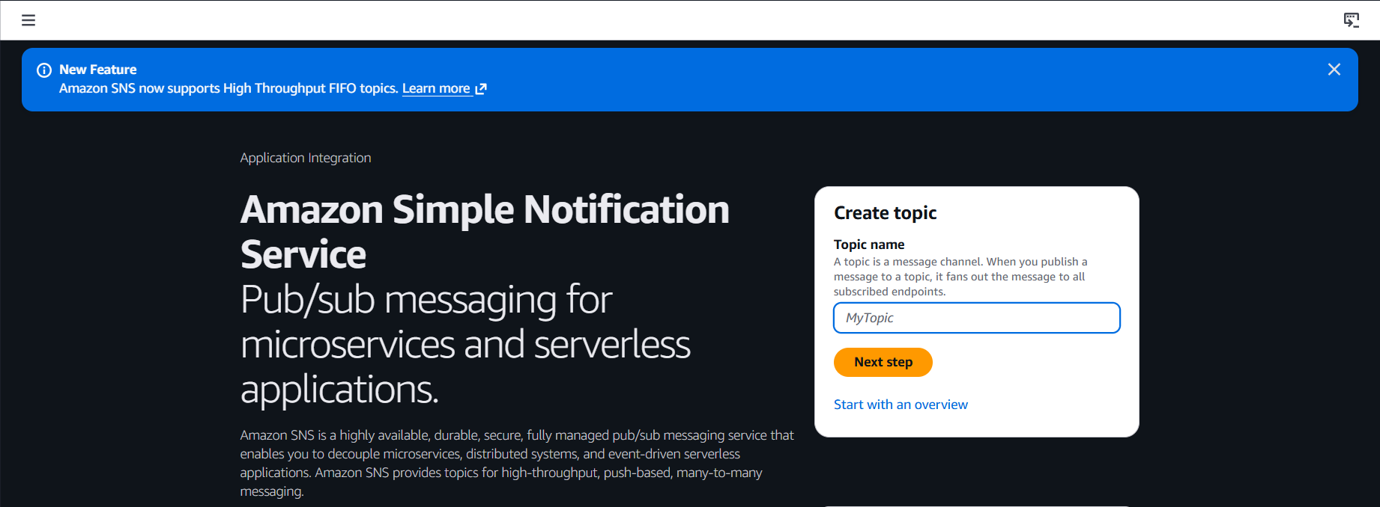

Step 2: Creating an SNS Topic
An SNS Topic is a communication channel to which publishers send messages and subscribers listen.
- On the Topics page, click the Create topic button.
- Under Type, select Standard (supports multiple protocols and high throughput).
- FIFO topics are used when strict message ordering is required.
- Under Name, enter: aditya-sns-topic
- Display name is optional — it appears in SMS messages as the sender name.
- Leave all other settings as default and scroll down.

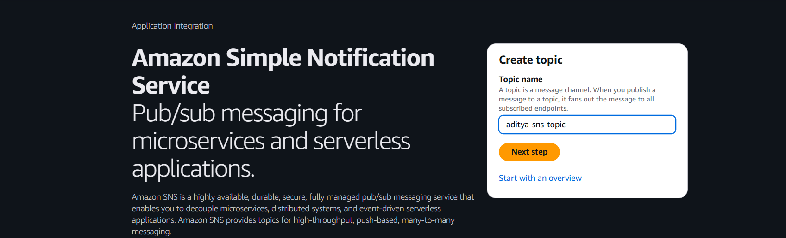

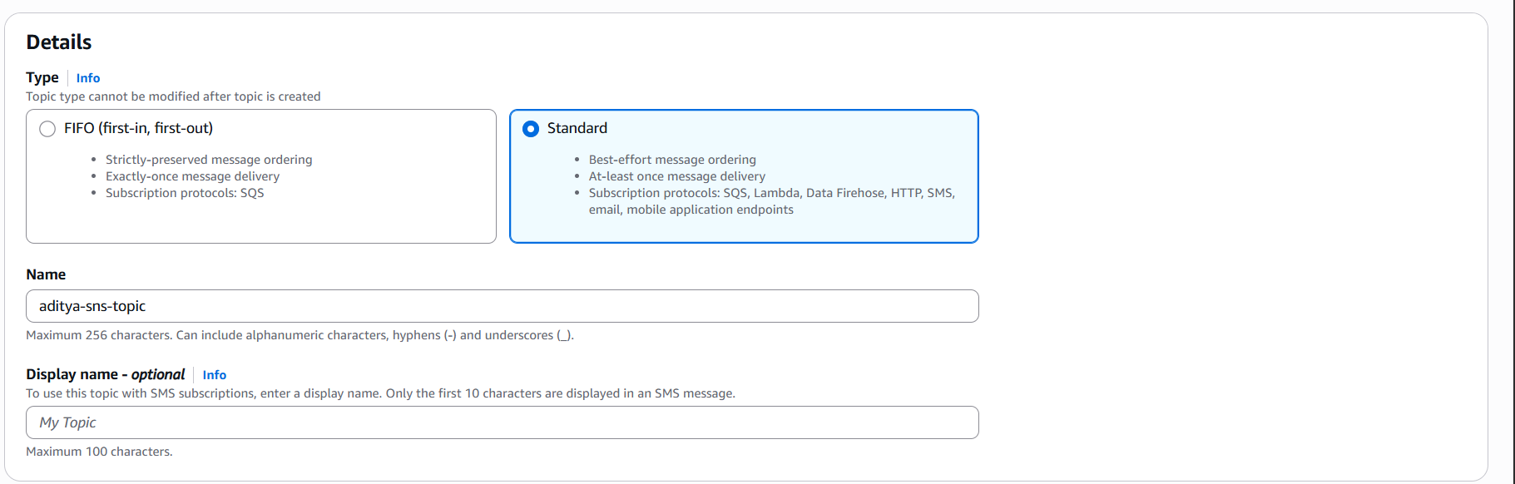

Step 3: Configuring Topic Settings
Additional settings can be configured to control access, encryption, and delivery policies.
- Encryption: Keep disabled for this lab (can be enabled with AWS KMS for sensitive data).
- Access policy: Keep the default — only the topic owner can publish and subscribe.
- Delivery retry policy: Defines how SNS retries failed deliveries to HTTP/HTTPS endpoints.
- Delivery status logging: Optionally enable to log delivery status in CloudWatch.
- Scroll down and click Create topic.

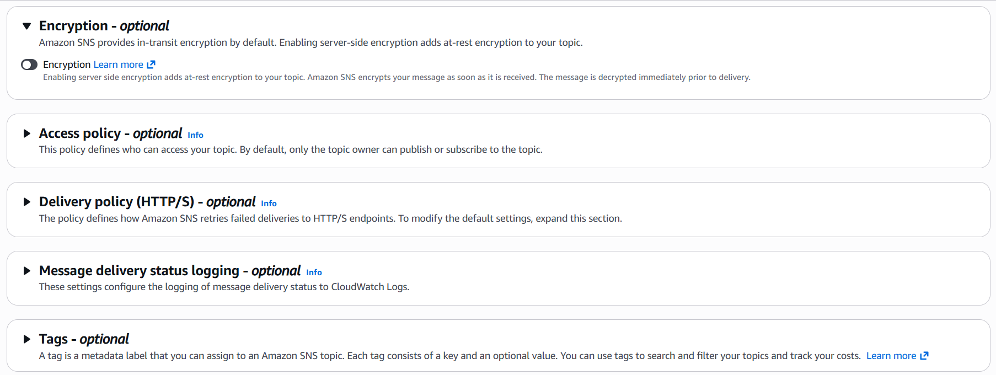

Step 4: Viewing the Topic Details
After creation, the Topic details page shows the ARN and configuration.
- The topic "aditya-sns-topic" is now created and visible on the Topics page.
- Click on the topic name to open its detail page.
- Note the Topic ARN (Amazon Resource Name) — it uniquely identifies this topic.
- The ARN format looks like: arn:aws:sns:region:account-id:topic-name
- This ARN is used when publishing messages programmatically.

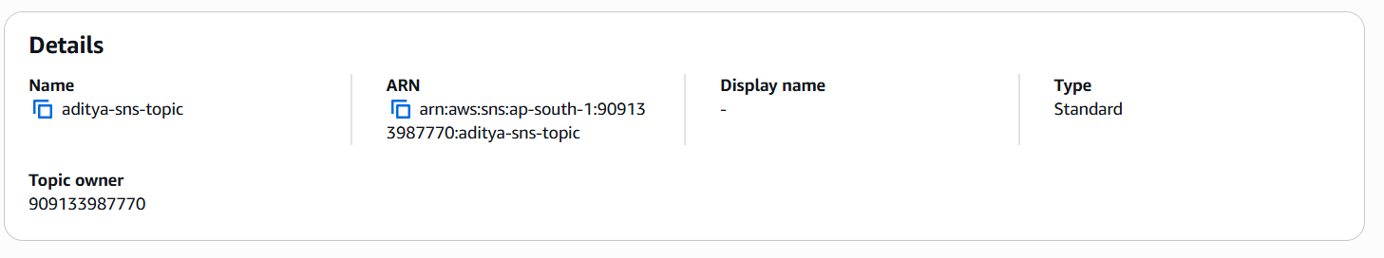

Step 5: Creating a Subscription
A subscription connects an endpoint (like an email address) to the SNS Topic to receive messages.
- On the Topic detail page, click the Create subscription button.
- Topic ARN is auto-filled with the current topic's ARN.
- Under Protocol, select Email from the dropdown.
- Under Endpoint, enter the email address: adityakumarkushwaha021@gmail.com
- Click Create subscription.
- The subscription status will show as PendingConfirmation until the email is verified.

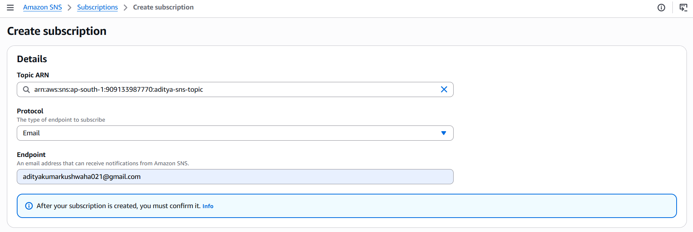
Step 6: Confirming the Email Subscription
AWS sends a confirmation email to the subscribed address — it must be confirmed before messages are received.
- Open the inbox of adityakumarkushwaha021@.com in your email client.
- Look for an email from AWS with subject: "AWS Notification - Subscription Confirmation".
- Open the email and click the Confirm subscription link inside.
- A browser page opens confirming: Your subscription to the topic has been confirmed.
- Go back to the AWS SNS Subscriptions page and refresh.
- The subscription status will now show as Confirmed.

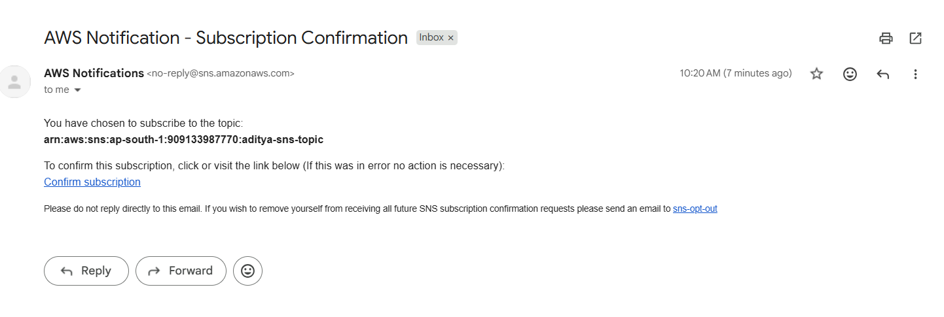

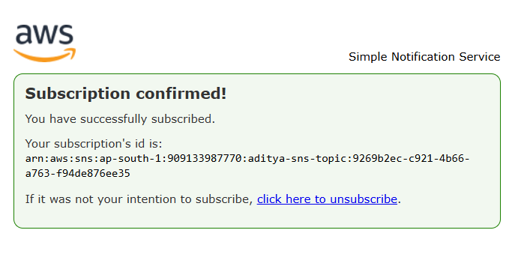

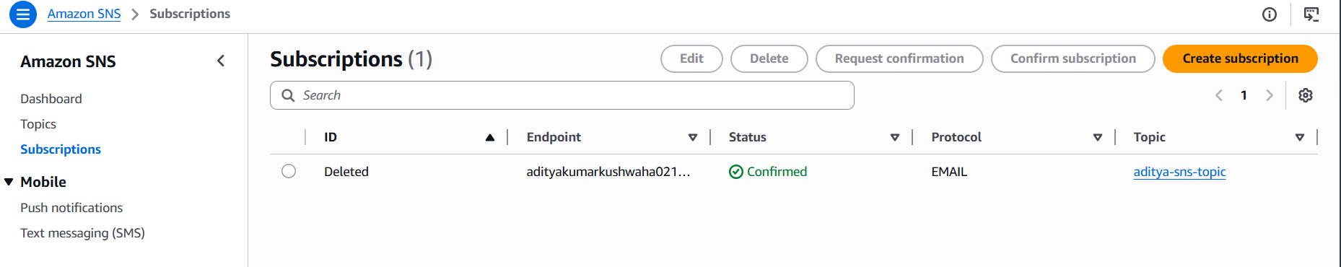

Step 7: Publishing a Message to the Topic
Once subscribed, messages can be published to the topic and all confirmed subscribers will receive them.
- On the Topic detail page, click the Publish message button.
- Under Subject, enter: Test Notification from AWS SNS
- Under Message body, select Identical payload for all delivery protocols.
- In the Message body text box, type your message:
- 'Hello! This is a test notification sent from Amazon SNS by Aditya Kumar Kushwaha.'
- Optionally add Message attributes for filtering.
- Click Publish message.
- A success banner will confirm the message has been published.

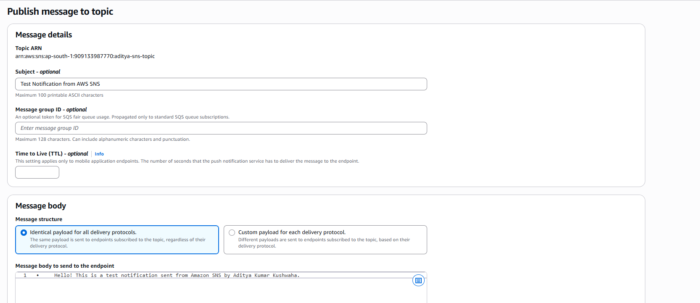

Step 8: Verifying Message Delivery
Check that the subscribed email address receives the published SNS notification.
- Open the inbox of adityakumarkushwaha021@gmail.com in your email client.
- A new email arrives with the subject: "Test Notification from AWS SNS".
- Open the email — the message body should contain the text you published.
- The sender will be no-reply@sns.amazonaws.com.

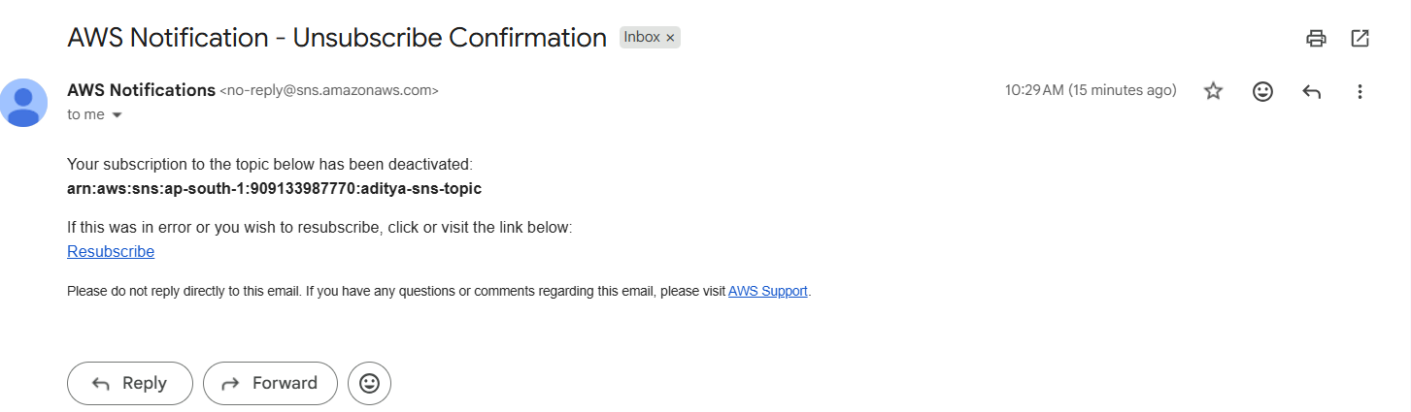

Step 9: Deleting the Topic and Subscriptions
After completing the lab, the SNS topic and subscriptions should be deleted to keep the account clean.
- Go to SNS > Subscriptions in the left panel.
- Select all subscriptions linked to your topic.
- Click Delete and confirm — all subscriptions are removed.
- Now go to SNS > Topics.
- Select "aditya-sns-topic" and click Delete.
- A confirmation dialog appears — type delete me and click Delete.
- The topic is permanently removed from your AWS account.

